**COMSATS** **University Islamabad, Lahore Campus**

**Department of Computer Science**

**Data Communication and Computer Networks**

**Assignment 2**

**Submitted to:**

*Sir Asad Mumtaz*

**Submitted by:**

*Mohammad Abuzar*

*SP19-BCS-089*

*Section B*

**Date:**

**April 23th, 2021**



# Ubuntu Installation Command /Steps:

1. Download ISO image file of Ubuntu Linux.
2. Download Virtual Box and make appropriate steps and select the ISO image file.
3. After Selection installation will took almost half an hour.
4. 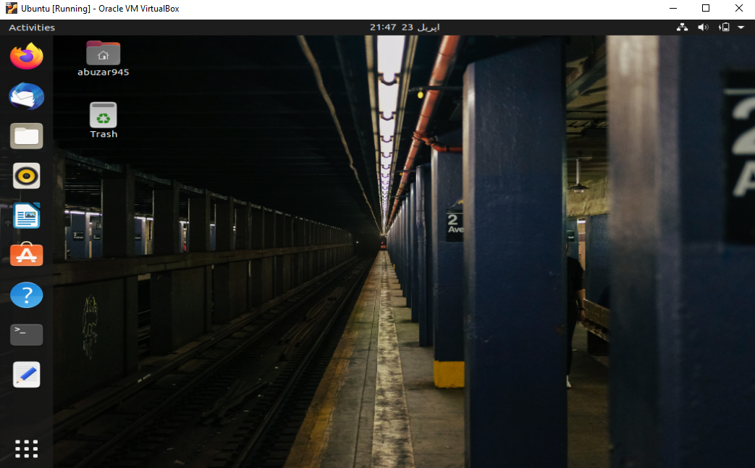And then you go here:

# NS2 installation commands /steps:

1. Open terminal in Ubuntu and type below command to install NS2:

*sudo apt-get install ns2*

1. Then press enter and after 10 minutes NS2 will install.
2. To check whether it is install or not just time below

*ns*

1. See in Screenshot that % sign in next line is proof of ns is installed.

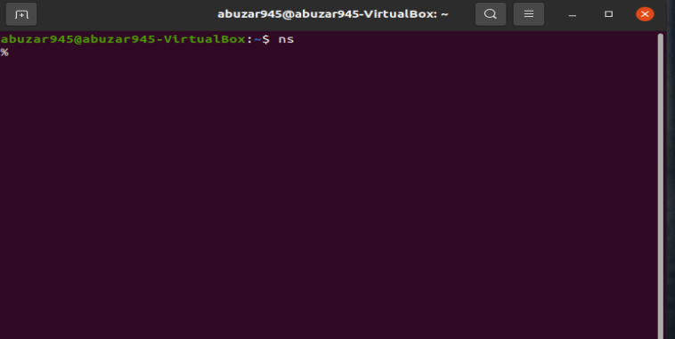

# Nam Installation Commands /Steps:

* Type below command in terminal

*sudo apt-get install nam*

* 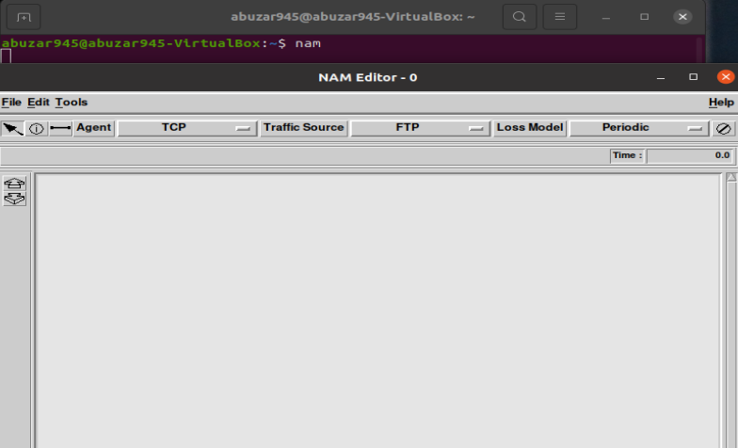After some time, it will have installed to check whether it is installed or not just type nam in terminal

# Xgraph Installation commands/Steps:

* For Xgraph I download it manually by using following command in Linux terminal

*xgraph_4.38_linux64.tar.gz*

* To install this, I just untar this folder by using following command in Linux terminal and run the package.

*tar xvfz xgraph_4.38 _linux64.tar.*

